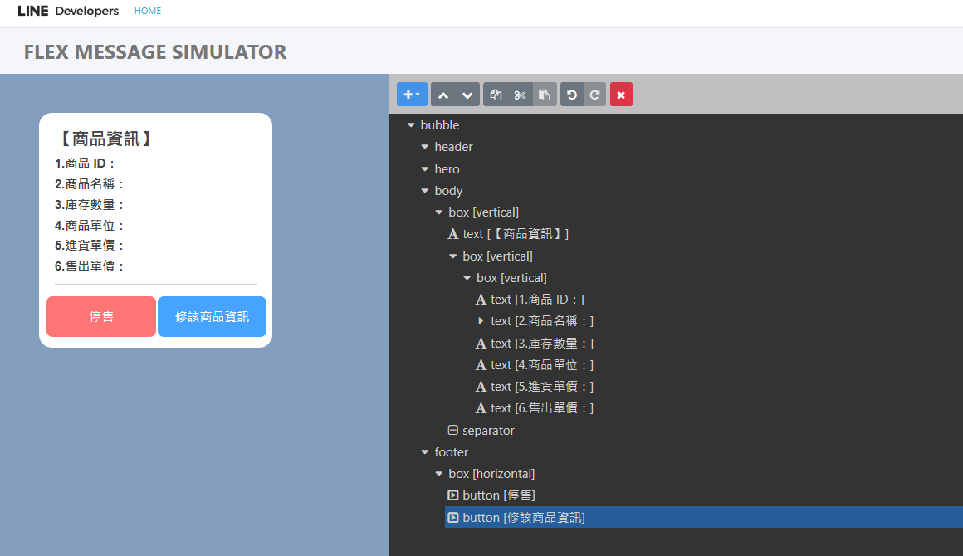

{

"type": "bubble",

"body": {

"type": "box",

"layout": "vertical",

"spacing": "xxl",

"contents": [

{

"type": "text",

"text": "【商品資訊】",

"size": "xl",

"weight": "bold"

},

{

"type": "box",

"layout": "vertical",

"spacing": "xl",

"contents": [

{

"type": "box",

"layout": "vertical",

"contents": [

{

"type": "text",

"text": "1.商品 ID：",

"weight": "bold",

"margin": "xs"

},

{

"type": "text",

"text": "2.商品名稱：",

"flex": 0,

"margin": "sm",

"weight": "bold",

"contents": []

},

{

"type": "text",

"text": "3.庫存數量：",

"weight": "bold",

"margin": "sm"

},

{

"type": "text",

"text": "4.商品單位：",

"weight": "bold",

"margin": "sm"

},

{

"type": "text",

"text": "5.進貨單價：",

"weight": "bold",

"margin": "sm"

},

{

"type": "text",

"text": "6.售出單價：",

"weight": "bold",

"margin": "sm"

}

]

}

],

"margin": "xs"

},

{

"type": "separator",

"margin": "lg",

"color": "#888888"

}

]

},

"footer": {

"type": "box",

"layout": "horizontal",

"contents": [

{

"type": "button",

"style": "primary",

"color": "#FF7575",

"margin": "none",

"action": {

"type": "message",

"label": "停售",

"text": "停售"

},

"height": "md",

"offsetEnd": "none",

"offsetBottom": "sm",

"offsetStart": "none"

},

{

"type": "button",

"action": {

"type": "message",

"label": "修該商品資訊",

"text": "hello"

},

"style": "primary",

"color": "#46A3FF",

"margin": "none",

"height": "md",

"offsetBottom": "sm",

"offsetEnd": "none",

"offsetStart": "xs"

}

],

"spacing": "none",

"margin": "none"

}

}